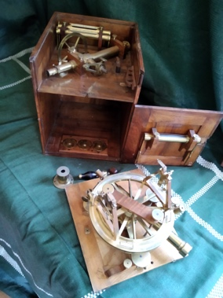
M133/1
“The Beaufort Theodolite”- by Reichenbach & Ertel, Munich. Shown here in original wooden case (M133/2, in store room) Door of upper part missing. Company started 1814, so probably made within a few years after this date.
Not on list of Maclear, T., Mems RAS, 20, 1, 1851. But see Maclear, T., 1866, “Verification and Extension …”, Admiralty, London, Page 399.
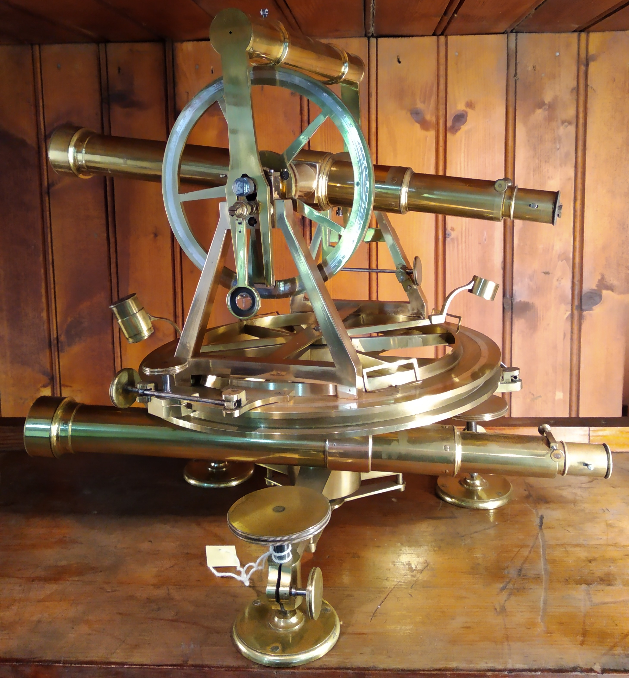
This was the “pet theodolite” of Sir Francis Beaufort and was sent to Maclear for use in his geodetic survey work. Beaufort was at the time Hydrographer of the Royal Navy and, as such, in charge of the Royal Observatories at Greenwich and the Cape.
(Left) assembled, as displayed.
Aperture ~29mm, F.L. ~ 35 cm.
It was donated to the Royal Observatory by Thomas Maclear’s son Admiral JP Maclear (See his letter dated 1901 November 8 in SAAO Archives A0025 “E Movable Property 1898-1908”. Mention made of its use by Captain Baily in his survey of 1859-62. Letter of thanks from Gill dated 1901 December 20).

