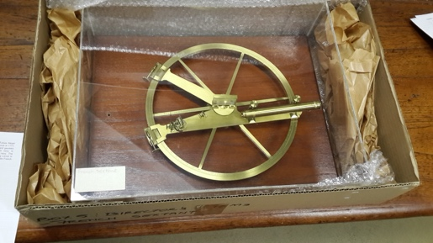
M134
Borda reflecting circle by Lenoir. In Perspex case (1785).
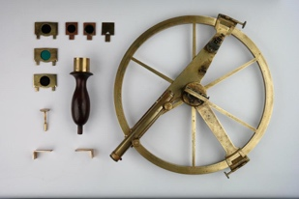
It bears the inscription “Donné Par le Roi à m^{r} de la Grandière garde de la marine. l’anné 1785. Lenoir Paris No 19.” The la Grandière family were nobles with naval interests. Mounted on a wooden base with a perspex cover. Two small items in the box of the Reichenbach & Ertel theodolite may be related to this: a black handle and a brass sleeve. See picture to right of a similar circle with accessories. [Note: No. 10 is the property of the National Museum of American History, Smithsonian, Washington DC. Number 23 is in the Museo della Specola in Bolgna, Italy. The illustrated one on the right is No 33, from a sale advertisement.]

